GRADE:3RD .  DATE: 25TH /MAY/2022.  NAME:  WORKSHEET (UNIT 16). | 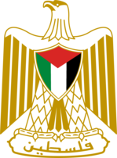 | MASQAT BASIC BOYS' SCHOOL.  MINISTRY OF EDUCATION.  DIRECTORATE OF EDUCATION\BIRZEIT.

Read and match:
a- I live in Amman. | 1- I'm from Palestine.
b-I live in Jerusalem. | 2- I'm from Jordan.
c-I live in London. | 3-Im from the United States.
d- I live in Washington. | 4-I'm from Britain.

Read and write.
beautiful Jerusalem Palestine Palestinian Arabic
1- I'm from ___________________ .
2- I'm _____________________ .
3- I speak __________________.
4- ___________________ is the capital of Palestine.
5- Jerusalem is a _________________________ city.

Write correctly.
live /in / I/ Bethlehem.


TEACHER: SA'ED FAR'OUN.

