Name:  Class:1st Grade  Date: |   الفصل الدراسي الأول  2020/2021م | Palestine State  Ministry of Education  Directorate of Tulkarm  Nazlat Issa Basic Boys' School

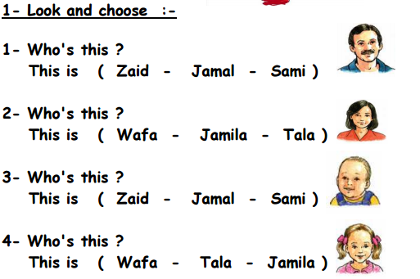
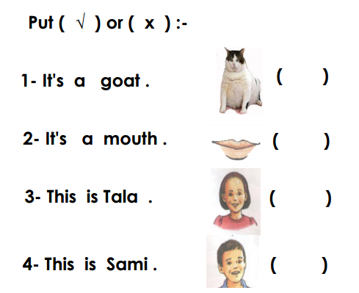
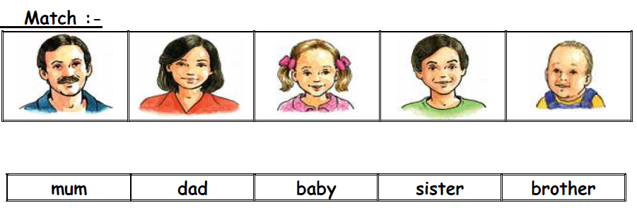
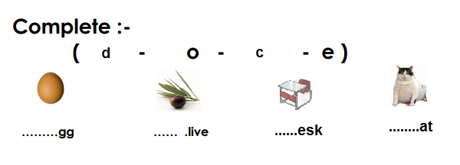
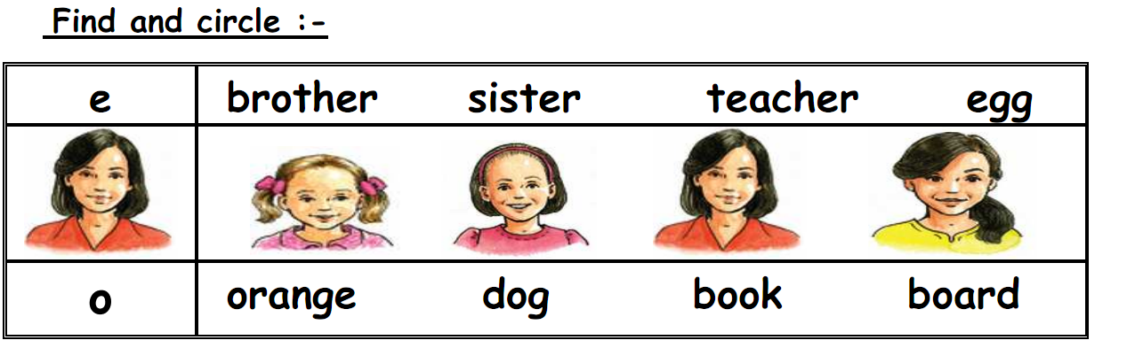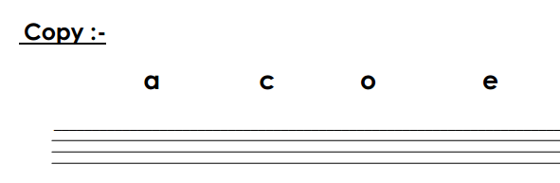
_____________________________________________________
The End T. Akram YounisGood Luck

