
Name:
Class:4th Grade
Time:
Date:

U--4
Palestine State
Ministry of Education
Directorate of Tulkarem
Nazlet Issa Basic Boys' School
----------------------------------------------------------------------------------------------------------------------------
Read the passage and answer:
" Let's go shopping. We need three kilos of potatoes, two cartons of milk and two bags of pasta. Fiona needs three packets of biscuits."
:Complete :-
1. Let's go …………………………( shopping – cooking ).
2. We need three kilos of ( biscuits – potatoes ).
Put ( √ ) or ( × )
1. We need three cartons of milk. ( )
2. Fiona needs three packets of biscuits. ( )
Answer
How many bags of pasta do we need ? ……………………………………………………
*******************************************************
Complete the dialogue:
( dinars – you- Good morning -Ahmad – Fine-pasta – would- much )
Good morning,……………………….. 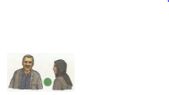 ……………………………, Hala
How are you ? …………………………….., thanks
What ………………. you like? I'd like bag of …………………….
Anything else? No, thanks. How …….……..is it?
Two ……………………………. Here ………………………….. are
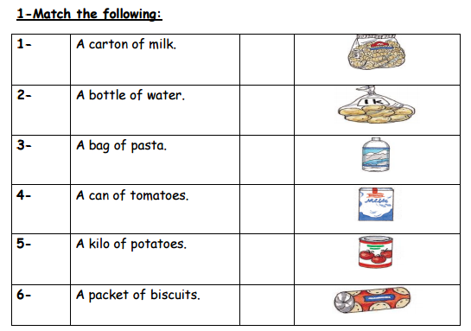
-Rearrange:
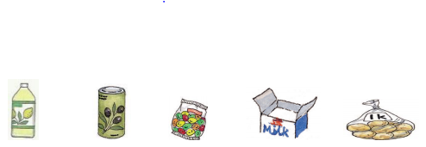
ttoleb anc abg tcaron loki
……………….. …………… …………… …..……………. ……………
----------------------------------------------------------------------------------------------------
-Choose:
1. How …………is it ? Five dinars. ( many – much – old)
2. It's a can of …………… ( potato – milk – fish)
3. I'd ……………..a bag of rice, please. ( like – bike – thank)
4. There are ………………..packets of biscuits. ( five – ten –seven ). 