
U-4
Palestine State
Ministry of Education
Directorate of Tulkarem
Nazlet Issa Basic Boys' School
Name:
Class:5th Grade
Time:
Date:

************************************************************************
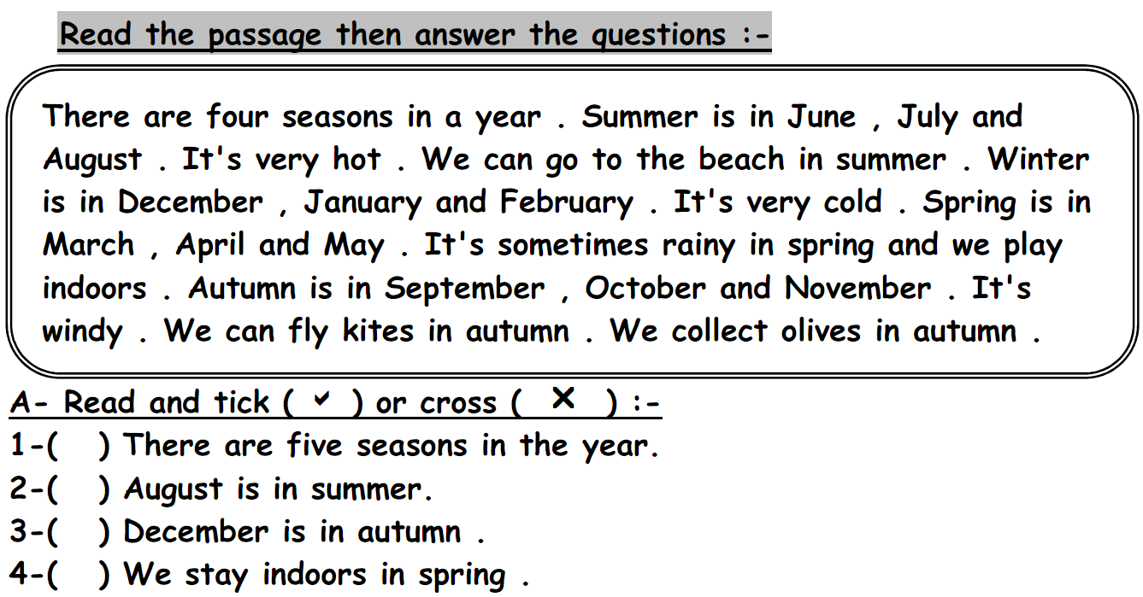

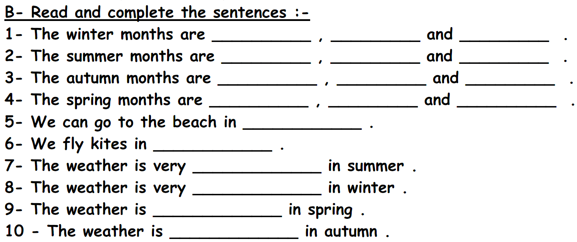
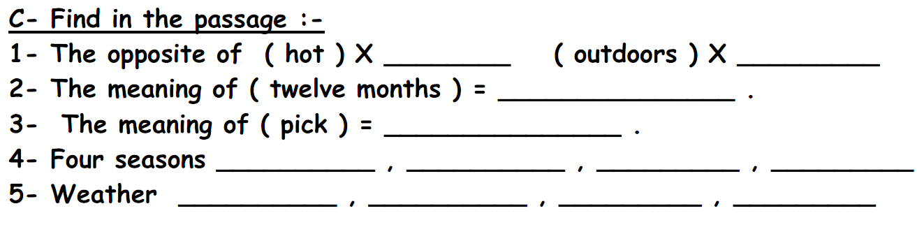

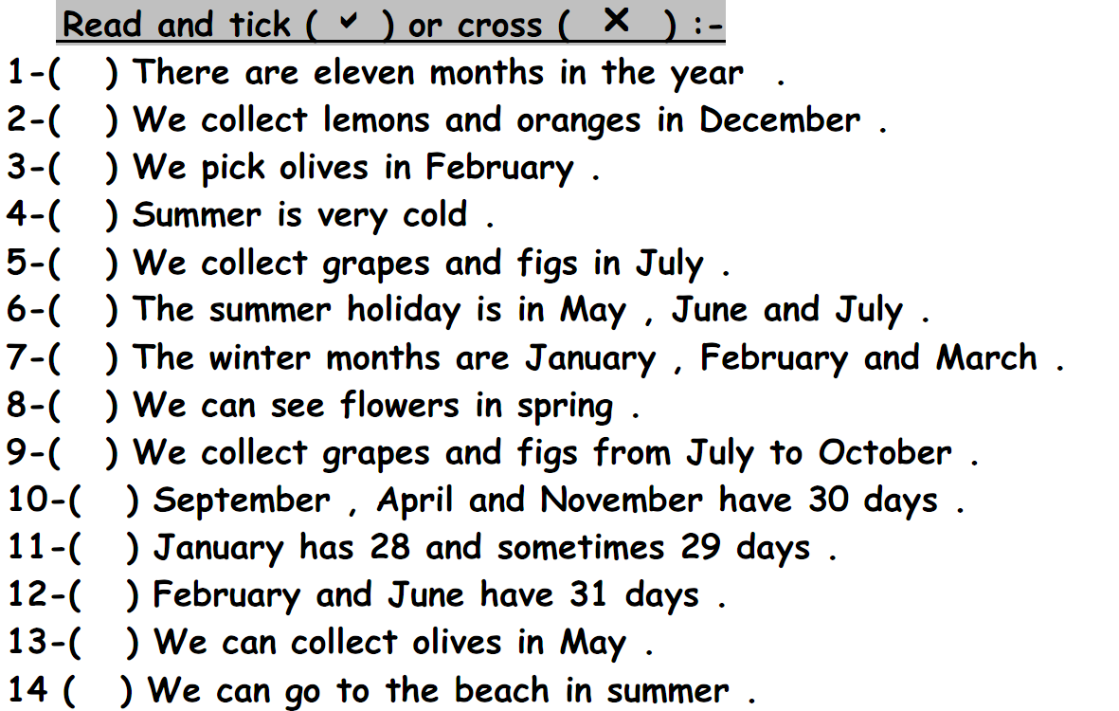
************************************************************************
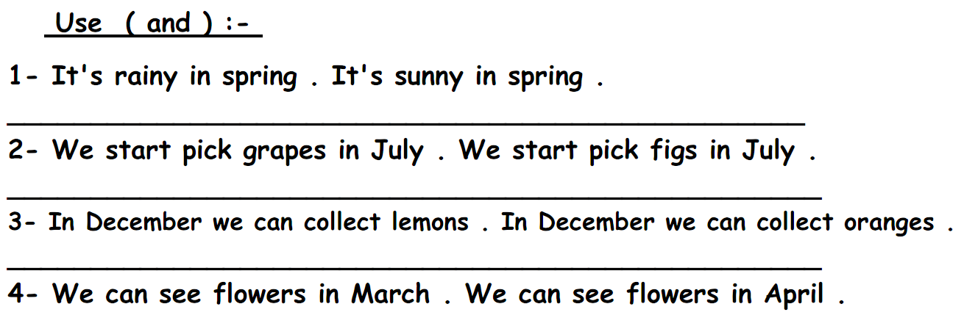
************************************************************************
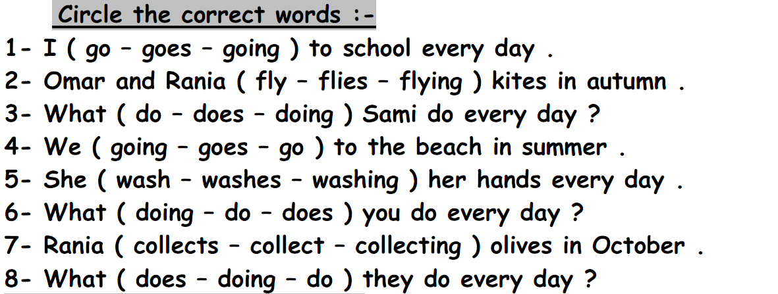
************************************************************************
The End
Good Luck Teacher: Akram Younis

