
U---1
Name:
Class:4th Grade
Time:
Date:

-------------------------------------------------------------------------
Palestine State
Ministry of Education
Directorate of Tulkarem
Nazlet Issa Basic Boys' School
1-Read the paragraph and answer:
I'm Fiona . I'm nine. I'm from London.
I have one brother and one sister.
2-Choose the right answer:
1. She's ……………….(Flona – Fiona)
2. She's from…………….(London – Nablus)
3. She's ………………(9-8).
4. She has …………..brother. ( 1 – 2)
-------------------------------------------------------------------------------------
6-Odd one out:
1. Mum – dad – Nablus – aunt.
2. Oxford- yellow – London – Ramallah.
3. reading – swimming – dancing – green
4. brother- two – nine – one
5. doctor - uncle – driver – nurse
6. what - how – where – my

7-Complete the missing letter:
(e - u – a – i )
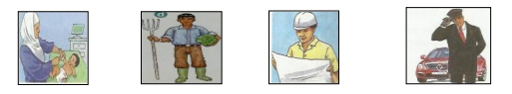
n_rse f_rmer _ngineer dr_ver
----------------------------------------------------------------------------------------
