
Name:
Class:2nd Grade
Tim e:
Date:

Palestine State
Ministry of Education
Directorate of Tulkarem
Nazlet Issa Basic Boy

s' School

U-1
-------------------------------------------------------------------------------------------------------
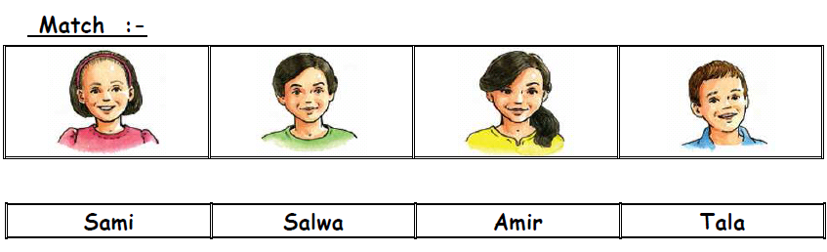

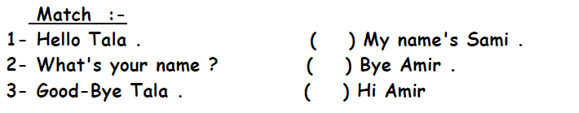

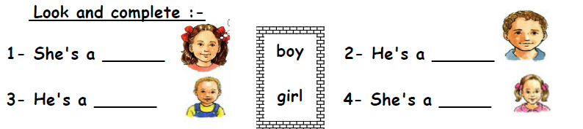

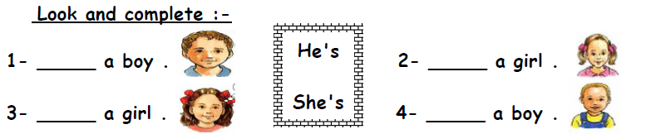

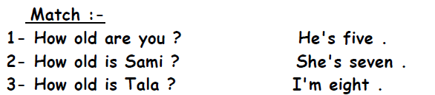

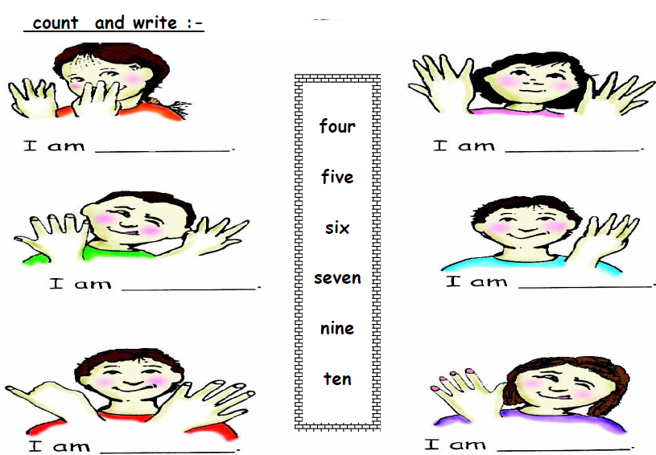

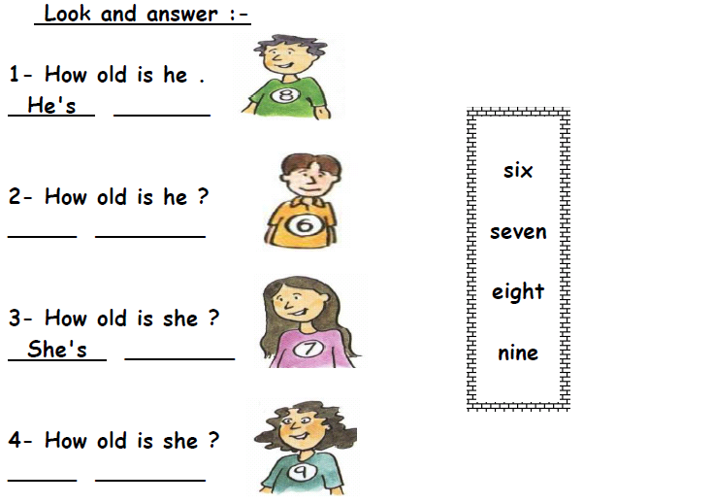

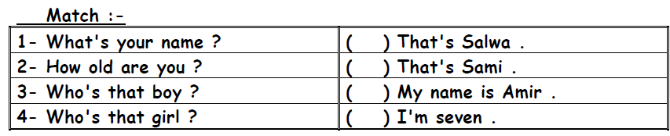

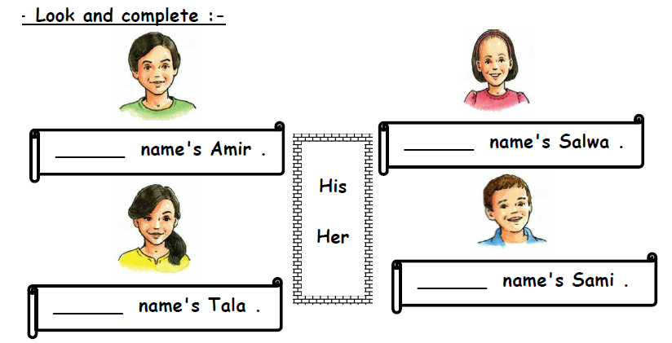

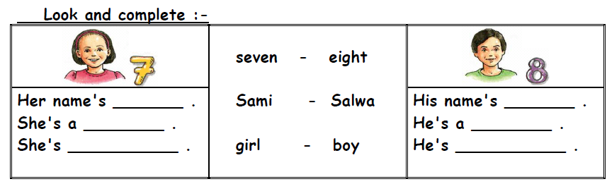

*********************************************************************

The End
Good Luck Teacher: Akram Younis

