
Palestine State
Ministry of Education
Directorate of Tulkarem
Nazlet Issa Basic Boys' School
Name:
Class:3 rd Grade
Time:
Date:

U-2 worksheet
------------------------------------------------------------------------------------------------------

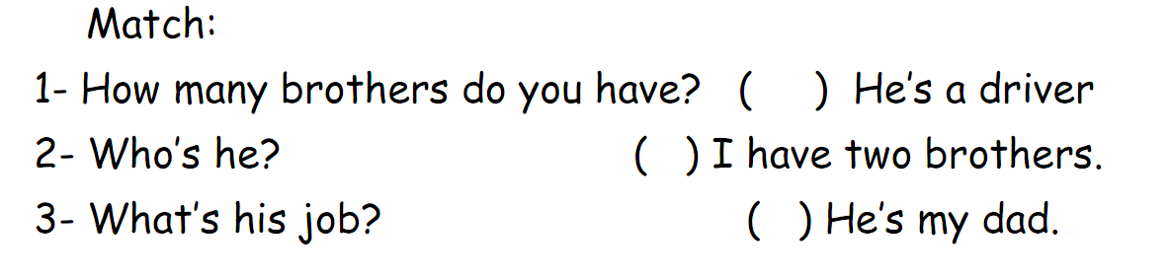
-------------------------------------------------------------------------------------------------------
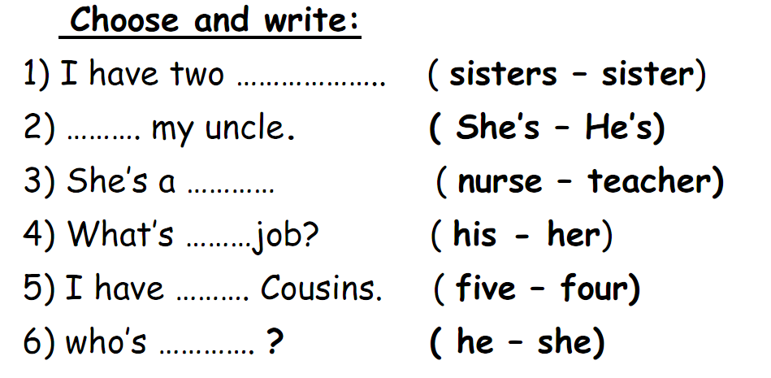

-------------------------------------------------------------------------------------------------------
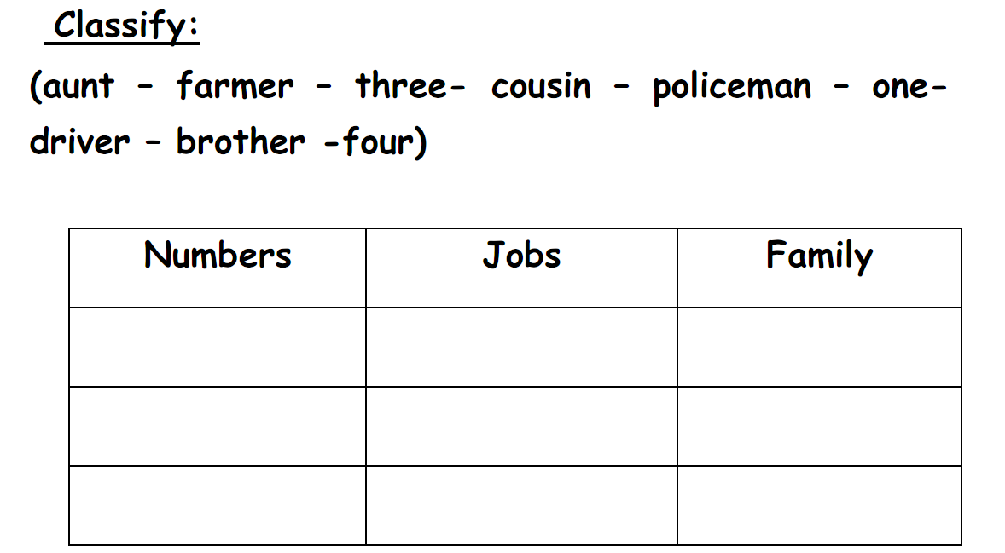

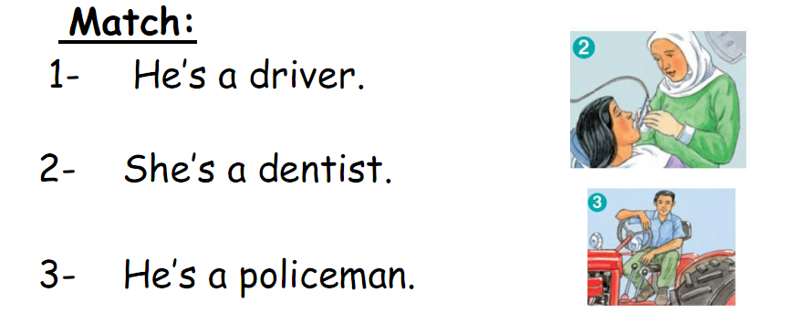
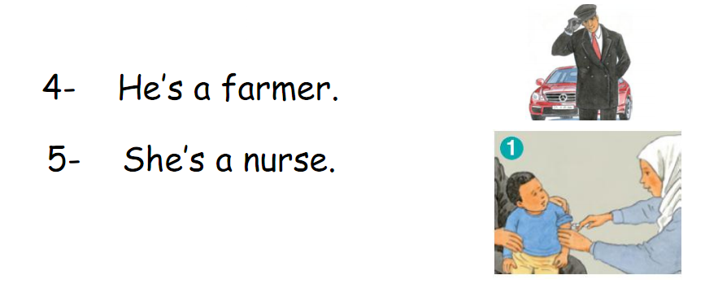

----------------------------------------------------------------------------------------------
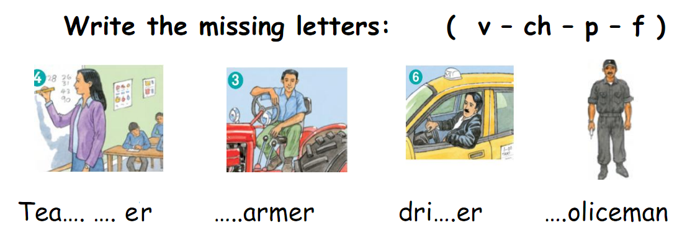
*********************************************************************
The End
Good Luck Teacher: Akram Younis

