Palestine State  Ministry of Education  Directorate of Tulkarm  Nazlat Issa Basic Boys' School |  | Name:  Class:1st Grade  Date:
U-3


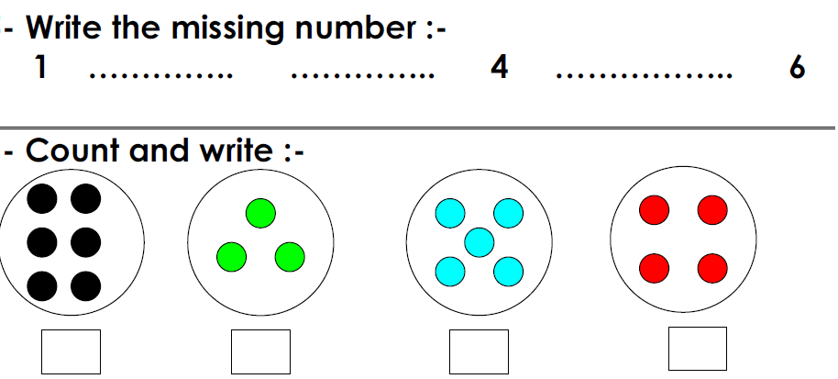
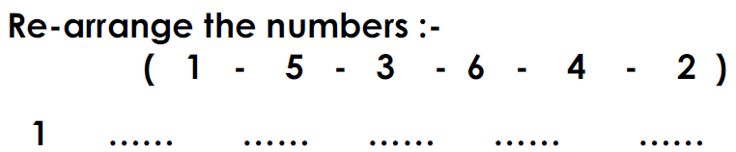

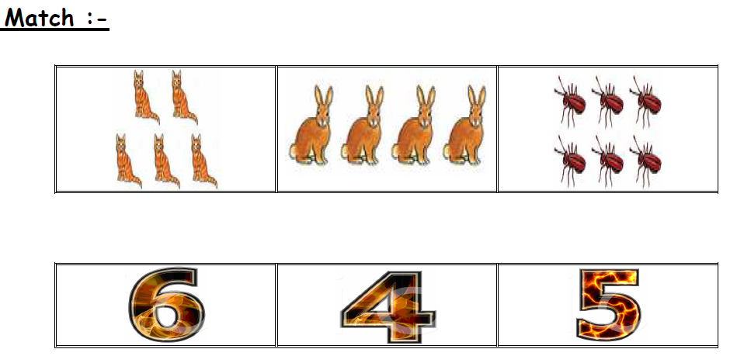
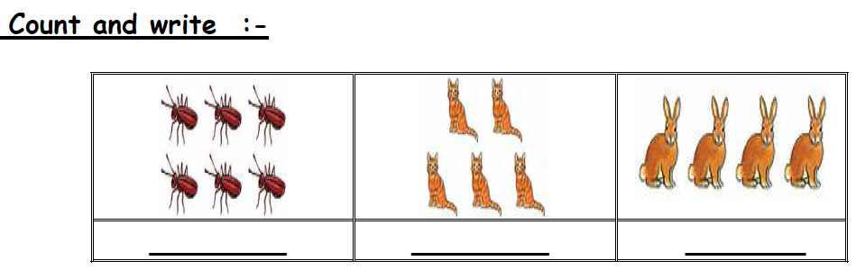

**************************************************************************
The End T. Akram Younis Good Luck

