Second Semester Final Exam 2013- 2014
Name:………………………………………………………... Class : the 6th ( )
2 m ) )
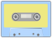
1-A)Listen and number the pictures:-
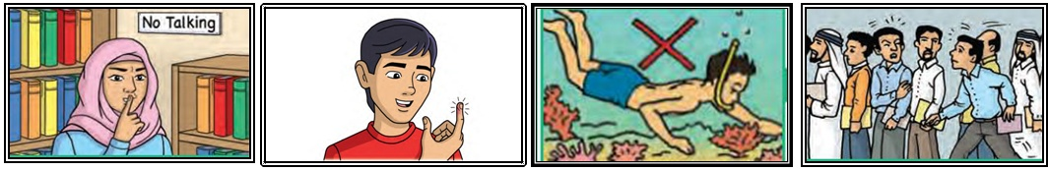
( ) ( ) ( ) ( )
4 m ) )

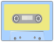
B)Listen to the dialogue and put ( ) or ( X) :-
1 - ( ) Amy's family were in a queue at the restaurant.
2- ( ) Amy wasn't angry.
3- ( ) The small boy pushed in politely.
4- ( ) His mother was sorry.
4 m ) )
2–A)Complete the following dialogue :-
exploring / so / space / Hello/ safe/ travel /agree /spaceship

Omar: | Hello, Ben
Ben: | __________ , Omar.
Omar: | What are you doing ?
Ben: | I'm reading about explorers. I think ________ the oceans is the most interesting.
Omar: | I don't think _______. I think exploring outer________ is the most exciting.
Ben: | I want to be like Ibn Battuta and __________ all over the Earth.
Omar: | I want to go around and around the Earth in a _____________.
Ben: | I don't think travelling by spaceship is very _____________.
Omar: | I don't _________.  2 m ) )
ماذا تقول في المواقف التالية B) What do you say when :-
1-You push in rudely.
a) I'm brave. b) It's my turn. c) I'm sorry.
2-You don't like someone's opinion.
a) Fantastic. b) I don't agree with you. c) That's great.
7 m ) )

Read and answer:
Once upon a time, there were two children. Their names were Tom and Jemima. One day they visited their uncle in the mountains. It was snowy. They made a snowman. The sun came out. It was hot. The snowman changed into water. In the evening, Tom wanted to play in the snow and make a snowman, but he can't. He has a fever.

1 m ) )
(A) Choose:-
1-The children visited their__________( friends – uncle ).
2-The snowman changed into __________ ( water – snow ).
1 m ) )
-(B) Read and put ( √ )or ( × ):
1- ( ) Jemima has a fever.
2- ( ) The children's uncle lives in the mountains.
(C)Get from the passage:-
3 m ) )
1-A family member:___________.
2-The opposite of : cold X _________.morning X __________.
3-The underlined pronoun" he " refers to__________.
4-Words that rhyme with: fun :________. /say : _______./cake : _______.
2 m ) )
(D)Answer:-
1- What happened to the snowman ?
_______________________________________________
2- Why can't Tom make a snowman in the evening?
_______________________________________________
3 m ) )

4) Read and classify:-
[ flu – quietly – polite – cold – loudly – honest ]
Adverbs | illnesses | Adjectives
5) Read and complete the sentences:-
5 m ) )
( stomachache – never – vapour – clearly – mud )
1- The Dead Sea _________ is a medicine.
2- I have _________been to the Dead Sea.
3- My stomach hurts a lot. I've got a _________.
4- When you boil the water, it changes into _________.
5- I can't hear you. Please speak __________.
5 m ) )
6) Choose the correct answer:-
1- Reem ( doesn't – don't ) mind Bilal telling his class about her.
2- Amy agrees ( to lend - lending ) her books.
3- She's good at ( give – giving ) good advice.
4-Omar and Rania ( talk – talks ) about Ibn Battuta.
5- Mr. Ali ( talk – talks ) about famous explorers.
6 m ) )
7) Do as shown in brackets:-اعمل كما هو مبين بين القوسين
1- how is the old man walking ( Write correctly )
________________________________________________________
2- Travelling into space is safe. ( Give your opinion )
________________________________________________________
3- Have you ever climbed a palm tree ? ( Answer )
________________________________________________________
4- I've been sick for last week. ( Correct the underlined word )
________________________________________________________
5- the sun - hot – First - makes - the water . ( re arrange )
________________________________________________________
6- flew - fell - swam – ridden. ( Odd one out )
2 m ) )

8) Handwriting:- أكتب بخط جميل
Plants can grow between the rocks.

With my best wishes T. Sami Abu Mustafa
دليل الاستماع


1-Listen and number the pictures:-
1-I have never explored under the oceans or seen coral.
2-The librarian says you must talk quietly in the library.
3- Aman pushed in so rudely in the queue.
4-Bilal is a brave boy he doesn't shout of pain .

2-Listen to the dialogue and put ( ) or ( X) :-
Rania: Hello, Amy
Amy: Hello, Rania
Rania: Where were you yesterday evening ?
Amy : Oh, we were waiting in a queue for our food at the restaurant.
Rania: Why are you angry ?
Amy : A small boy pushed in so rudely.
Rania : Oh, what did you say?
Amy: Dad quietly told his mother there was a queue and she was sorry.

للمزيد من امتحانات الصف السادس لغة انجليزية الفصل الثاني
https://www.wepal.net/library/?app=content.list..1&level=6&semester=2&subject=5&type=2

