4th Grade Final Exam Second Semester
1. Listen and match.
1 | Jamal | ........ | helped his aunt with the donkeys
2 | Hala and Bilal | ........ | helped his uncle with the sheep
3 | Walid | ........ | collected the eggs
4 | Fiona and Nour | ......... | watched the ducks
2. Listen and put ( ) or ( X) .
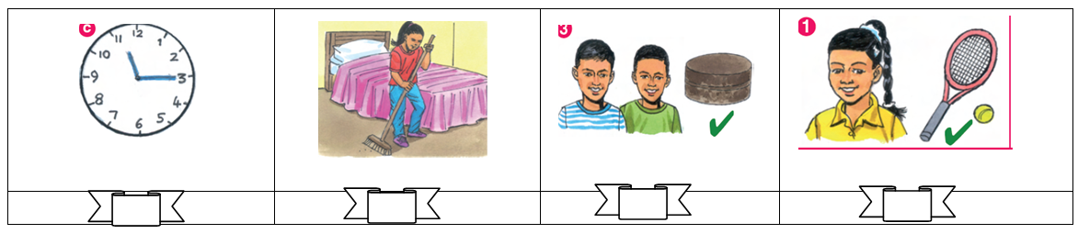
3. Listen and circle.
- In Britain school starts at 8:30 / 8:45.
- Fiona liked the flowers / butterflies.
- I never /sometimes do my homework at night.
- Hala adds one / two spoons of nuts.
__________________________________________________________________________
4. Complete the dialogue.
Brush – Friday – do - see

- What are we going to do on _________________ ?
- I am going to __________________ Al-Aqsa Mosque.
- Do you _____________ your teeth in the morning?
- Yes, I ___________
5. Choose.
Fiona’s family is going to visit ........
a. Haifa
b. Hebron
c. Bethlehem
6. Choose the correct answer.
- To make a cake we need { flour – chicken – tomatoes }
- There are donkeys. There { is – aren’t – are } sheep.
- 10 + 10 + 10 + 5 = { twenty-five – thirty-five – forty-five }
- The baker’s is on the { left – between – milk }

6. Match with pictures.
1. I can speak Arabic.
2. He can’t build a snowman.
3. I bought bananas.
4. He bought bread.
7. Correct the underlined mistakes.
- He always clean his bedroom. ( _______________)
- How much eggs? 6 eggs. ( _______________)
- In Monday we are going to visit Jerusalem. ( __________ )
8. Complete.
going
- Bilal is _____________ to visit Haifa.
six
ride
- I can____________ a bike.
- We need __________ cups of milk.
8. Look and write.
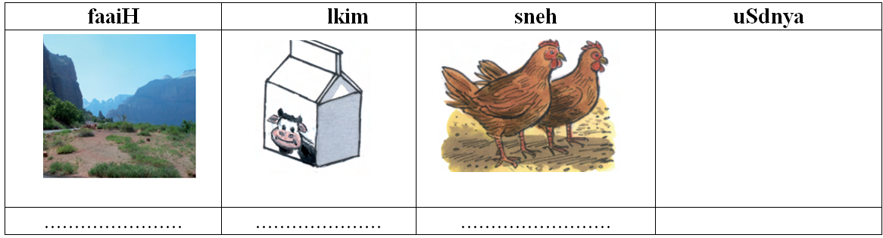
9. Write.
- dance / dabka / we / can ___________________________________________________
10. Classify.
Cities المدن | Habitsالعادات | Hebron get up  Brush Bethlehem  Jerusalem wash

12. Copy
I sometimes get up early

للمزيد من امتحانات اللغة الانجليزية للصف الرابع الفصل الثاني
https://www.wepal.net/library/?app=content.list&level=4&semester=2&subject=5&type=2

Listening Material
1. Listen and match
- Hamzah always brushes his teeth
- Fiona never helps her mum
- Walid sometimes brushes the dishes
- Hala never gets up late.
2. Listen and put (T ) or (X)
- What’s the time? It’s nine o’clock. (X)
- Fiona always cleans her bedroom. (X)
- Hamzah can run. ( T )
- Walid can’t swim in the sea. ( X )
3. Listen and circle.
- In Palestine school starts at 700
- Hala liked the giraffes
- I always do my homework
- Hala puts one cup of flour

