Ministry of Education& Higher Education  Directorate of Khan-yunis  Time: An hour and half  Date: / /  مجموع العلامات 40 /علامة | الإجابة النموذجية لامتحان  الصف الخامس الأساسي  الفترة المسائية |   دولة فلسطين  وزارة التربية والتعليم العالي  مديرية التربية والتعليم خان يونس

(4 Marks) I-Listening
1-Listen and circle: (2 points)
a- The Olympic stadium is a new (place - building).
b- Omar and his sister Rania are (twins - parents).
2-Listen and number the pictures: (2 points)









3

1

4
2

(6 Marks) II-Speaking

3-Match the part A with suitable from part B: (2 points)

(B) |  | (A)
My favourite sport is Basketball. | ( d ) | a- Who is swimming?
We are going to fly kite. | ( c ) | b- Can you go hiking in a valley?
Yes, I can. | ( b ) | c- What are we going to do in October?
Omar is swimming. | ( a ) | ?d- What is your favourite sport

4-Complete thefollowing dialogue:(4 points)

doing - Ben - Hello - helping
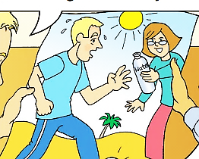
Omar : Hello Ben.
Ben : HelloOmar
Omar : What is your mum doing?
Ben : She is helpinghim?
(8 Marks) III-Reading

5-Read the passage then answer the question:
Ben, Omar, Amy and Rania are drinking lemonade in the kitchen. They are looking at photos. Ben is showing Omar a photo of the Olympic stadium in London. Rania is showing a photo of the cable cars in Jericho and a photo of wadi al-Qilt. Amy is holding a photo of a boat. It is in the river.

A)Answer the following question: (1 points)
a- Where is the Olympic stadium?
The Olympic Stadium In London.
B) Put (T) or (F):(4 points)
a- Ben, Omar, Amy and Rania are drinking lemonadein the kitchen.
b- They are looking atphotos.
c- Rania is showing a photo of the cablecars in Jericho.
d- Amy is holding a photo of aboat.

C) Find in the passage:(3 points)

a- A name of * drink lemonade*roomkitchen.
b-The underlined words (It) refers to a boat.
(8 Marks) IV-Vocabulary

6-Complete the sentences from words in the box:(4points)
programmes – cool – seventh - strong
a-It is coolin April.
b- Dwight Howard has strongshoulders and very strong arms.
c-These sports TV programmesare for Sundays.
d- Friday is the seventhday of the week.

7-Write the words under the pictures: (4points)
skipping – twins – heavy - boat



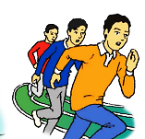
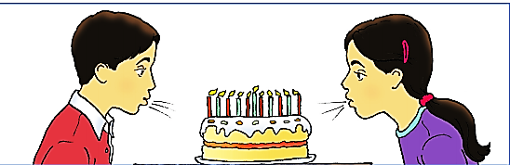
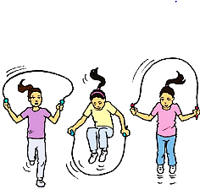
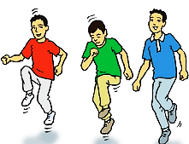

1-twins 2- boat 3- skipping 4- heavy
(8 Marks) VI-Language
8-Choose the correct answer: (4points)
a- I (doesn’t - don’t) have sisters.
b- He (has – have) seven brothers.
c- She (jump - jumps) every day.
d- His father (taking – is taking) a photo now.

9-Correct the underlined mistakes: (4 points)
a- Amy is (faster).(fast)
b- The pencil is (light) than the eraser. (lighter)
c- The plane is the (expensive). (most expensive)
d- Cartoon is (interesting) than the news. (more interesting)
(6 Marks) V-Writing

10-Re –arrange the words to make correct sentences:(1point)

Omar - in - the - Basketball - is - seventh - race.
Omar is seventh in the Basketball race.

11–Write correct sentences using (and):(2 points)
a- We love Raina. We love Amy.
We love Rania and Amy.

b- In summer we collect olives. In summer we collect figs.
In summer we collect olives and figs.

12-Copy the following sentence:(3points)

We love English Language

With my best wishes

